Edututor AI – Personalized Learning & Tutoring Platform

Team Leader: Mohammad Shamsheer T.A

Team Member: Nagaraj.D

# 1. Introduction

Edututor AI leverages artificial intelligence to transform education by providing personalized, adaptive, and accessible tutoring. Unlike traditional one-size-fits-all learning, Edututor AI tailors lessons to each student’s pace, style, and strengths. It aims to reduce learning gaps, promote digital literacy, and create an inclusive ecosystem for students, teachers, and institutions.

# 2. Project Overview

Edututor AI is an intelligent tutoring system that provides real-time support in academics, skill-building, and exam preparation. By combining natural language processing, adaptive learning, and predictive analytics, the platform creates an engaging and effective learning journey for students of all backgrounds.

# 3. Objectives

- Personalized Learning: Adapt content to students’ levels and learning styles.

- 24/7 Digital Tutor: Provide instant doubt-solving and academic support.

- Support Educators: Assist teachers with lesson planning, analytics, and grading.

- Accessibility & Inclusivity: Multilingual, voice-enabled, and affordable.

- Skill Development: Beyond academics—career guidance, soft skills, and digital literacy.

# 4. Core Features

1. AI-Powered Learning Hub: Interactive lessons, quizzes, and study guides with multilingual support.

2. Adaptive Tutoring System: Personalized progress tracking and smart recommendations for improvement.

3. Virtual Classroom & Collaboration: Live sessions, group study, and peer-to-peer help.

4. Exam Prep & Assessments: AI-generated mock tests and performance analytics.

5. Teacher & Parent Dashboards: Insights on student progress and communication tools for mentoring.

# 5. Target Users

- Students: School, college, and competitive exam aspirants.

- Teachers & Tutors: For classroom support and resource management.

- Parents: To track children’s performance.

- Educational Institutions: To enhance teaching methods.

# 6. Technology Stack

- AI & NLP Models: Adaptive learning, doubt-solving, essay evaluation.

- Machine Learning Analytics: Performance prediction & recommendations.

- Cloud Infrastructure: Scalable learning access.

- Mobile & Web App: Cross-platform accessibility.

- Future Integration: AR/VR immersive learning.

# 7. Implementation Roadmap

Phase 1: Research & design (curriculum mapping, AI framework).

Phase 2: MVP development (AI tutor, learning hub).

Phase 3: Pilot testing (selected schools/regions).

Phase 4: Expansion (multilingual, VR/AR, global rollout).

# 8. Expected Impact

- Improved learning outcomes and reduced dropout rates.

- Affordable access to quality education.

- Empowered teachers with AI support.

- Bridging digital divide with inclusive tools.

# 9. Challenges & Risk Mitigation

- Digital Divide: Offline/low-data solutions.

- Data Privacy: Secure handling of student data.

- AI Bias: Regular audits and ethical AI frameworks.

- Adoption Barriers: Teacher training and awareness campaigns.

# 10. Future Enhancements

- AR/VR classrooms for immersive learning.

- Gamified learning to increase engagement.

- Blockchain certificates for verifiable achievements.

- AI career mentor for skill-based guidance.

# 11. Reference Code (Screenshots & Steps)

Step 1: Import Libraries & Load Model

The system first imports Gradio and HuggingFace libraries, then loads a Question-Answering model. This allows Edututor AI to answer questions based on study notes.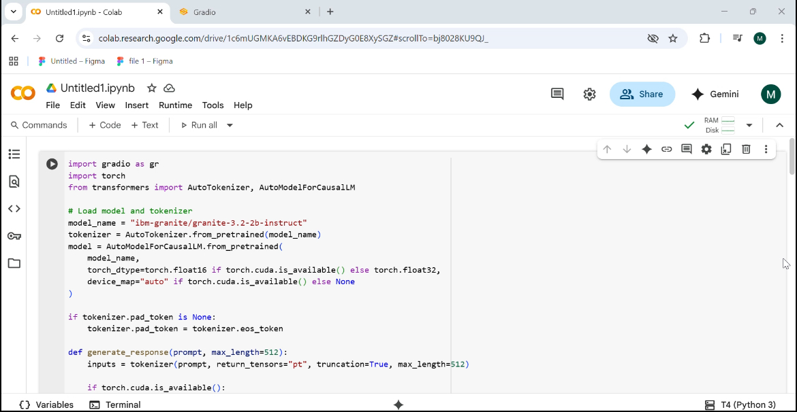

Step 2: Build Gradio Interface

A tabbed interface is created with two tabs: Ask Doubts and Exam Prep. This structure organizes student interactions effectively.

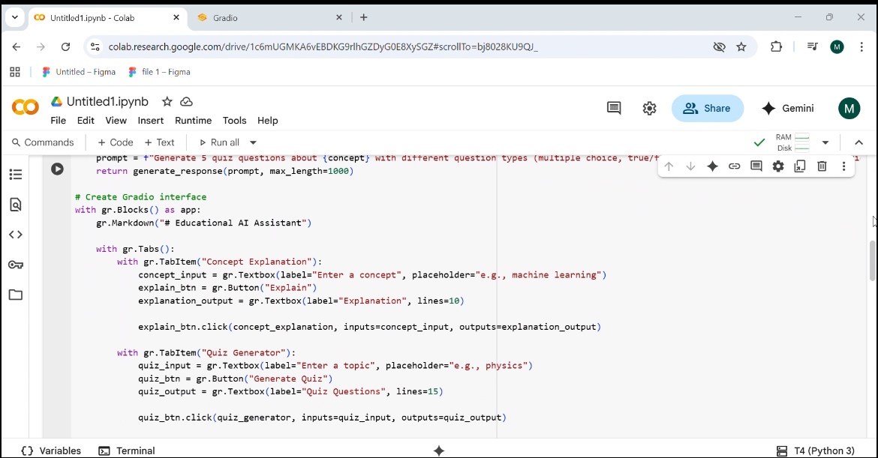

Step 3: Ask Doubts TabStudents can input a question and provide their study notes. The AI processes these and returns the most relevant answer.

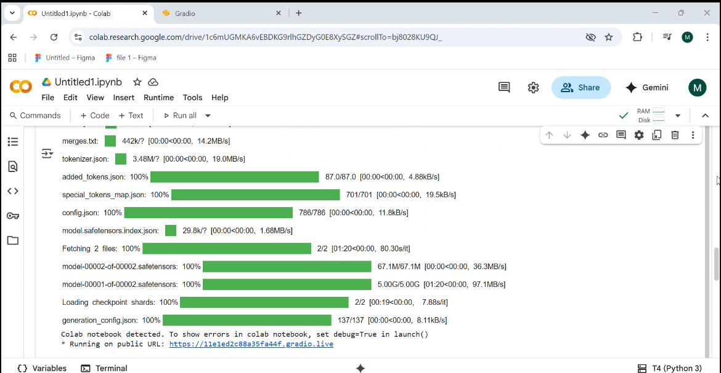

Step 4: Exam Prep Tab

A placeholder for future enhancements like AI-generated quizzes, flashcards, and performance analytics.

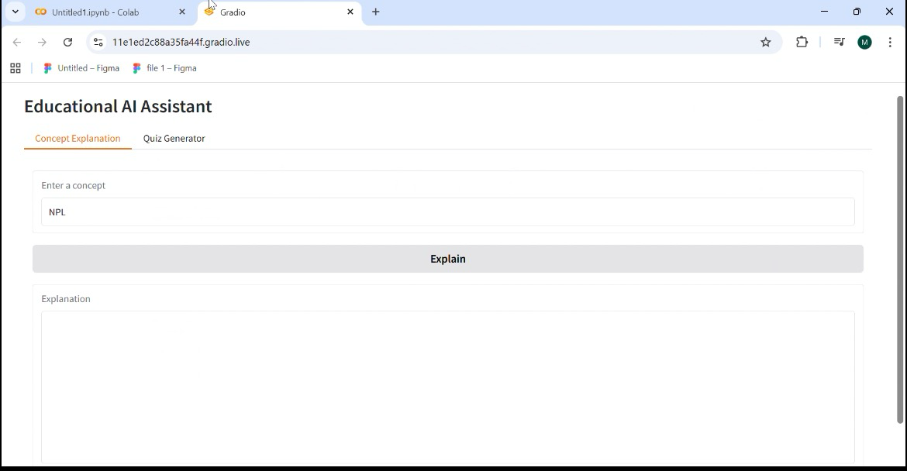

Step 5: Output

The application launches successfully, and students can interact with Edututor AI in real time.

